**For display in 1.54 inch e-Paper Module Using ESP8266:**

First select an image for display

**Go to The link:**

1. For image resize height and width before using GIMP software go to link------

[http://www.simpleimageresizer.com/upload#](http://www.simpleimageresizer.com/upload)

1. **After fixing the image size upload the image in the GIMP software for Epaper display, we need to convert the image using this link for following instructions using GIMP software 🡪**

**Go to link below**.--------------------------------https://www.twobitarcade.net/article/displaying-images-oled-displays/

1. For PGM or PBM image resize in OLED

After uploading an image in **GIMP software**, you need to convert images to 1-bit-per-pixel in GIMP through the Image -> Mode -> Indexed...

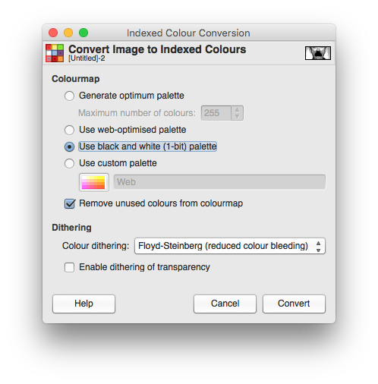

If you're image is already in an indexed format this won't be available. So convert back to RGB/Grayscale first, then re-select Image **🡪** Mode **🡪**Indexed.

For saving the PBM (recommended) or PGM, then go to the **File** in the **GIMP** software, select **export as** and select picture formatPGM, PBM and thenselect Raw mode, not ASCII.

**II)** For image resize EPAPER

First we have to resize image using this link

[http://www.simpleimageresizer.com/upload#](http://www.simpleimageresizer.com/upload)

And give the height and Width multiple of **eight** to resize the image by following the **e-paper display** size.

For Binary **(.bin)** imageformatfirst we have to follow (II) the given instruction then go to above instruction **(2)** for making the image into PGM format after doing this**🡪** download the **OLED FILE**

using this link

<http://download.martinfitzpatrick.name/oled-sample-images.zip>

Unzip this file put into a folder. Find the pack.py file folder.

Put the PGM format image into pack.py file folder. In folder go to the cmd

Write the command into the cmd as an example are given below(image file name = **‘desh.pgm’**)

**Python 🡪space** **🡪pack.py🡪space🡪desh.pgm**

**🡪**Press Enter

**dir 🡪press enter**

**dir 🡪space *.bin**

**🡪Press enter**

**Then we find this desh.bin image file which are created in pack.py file folder.**